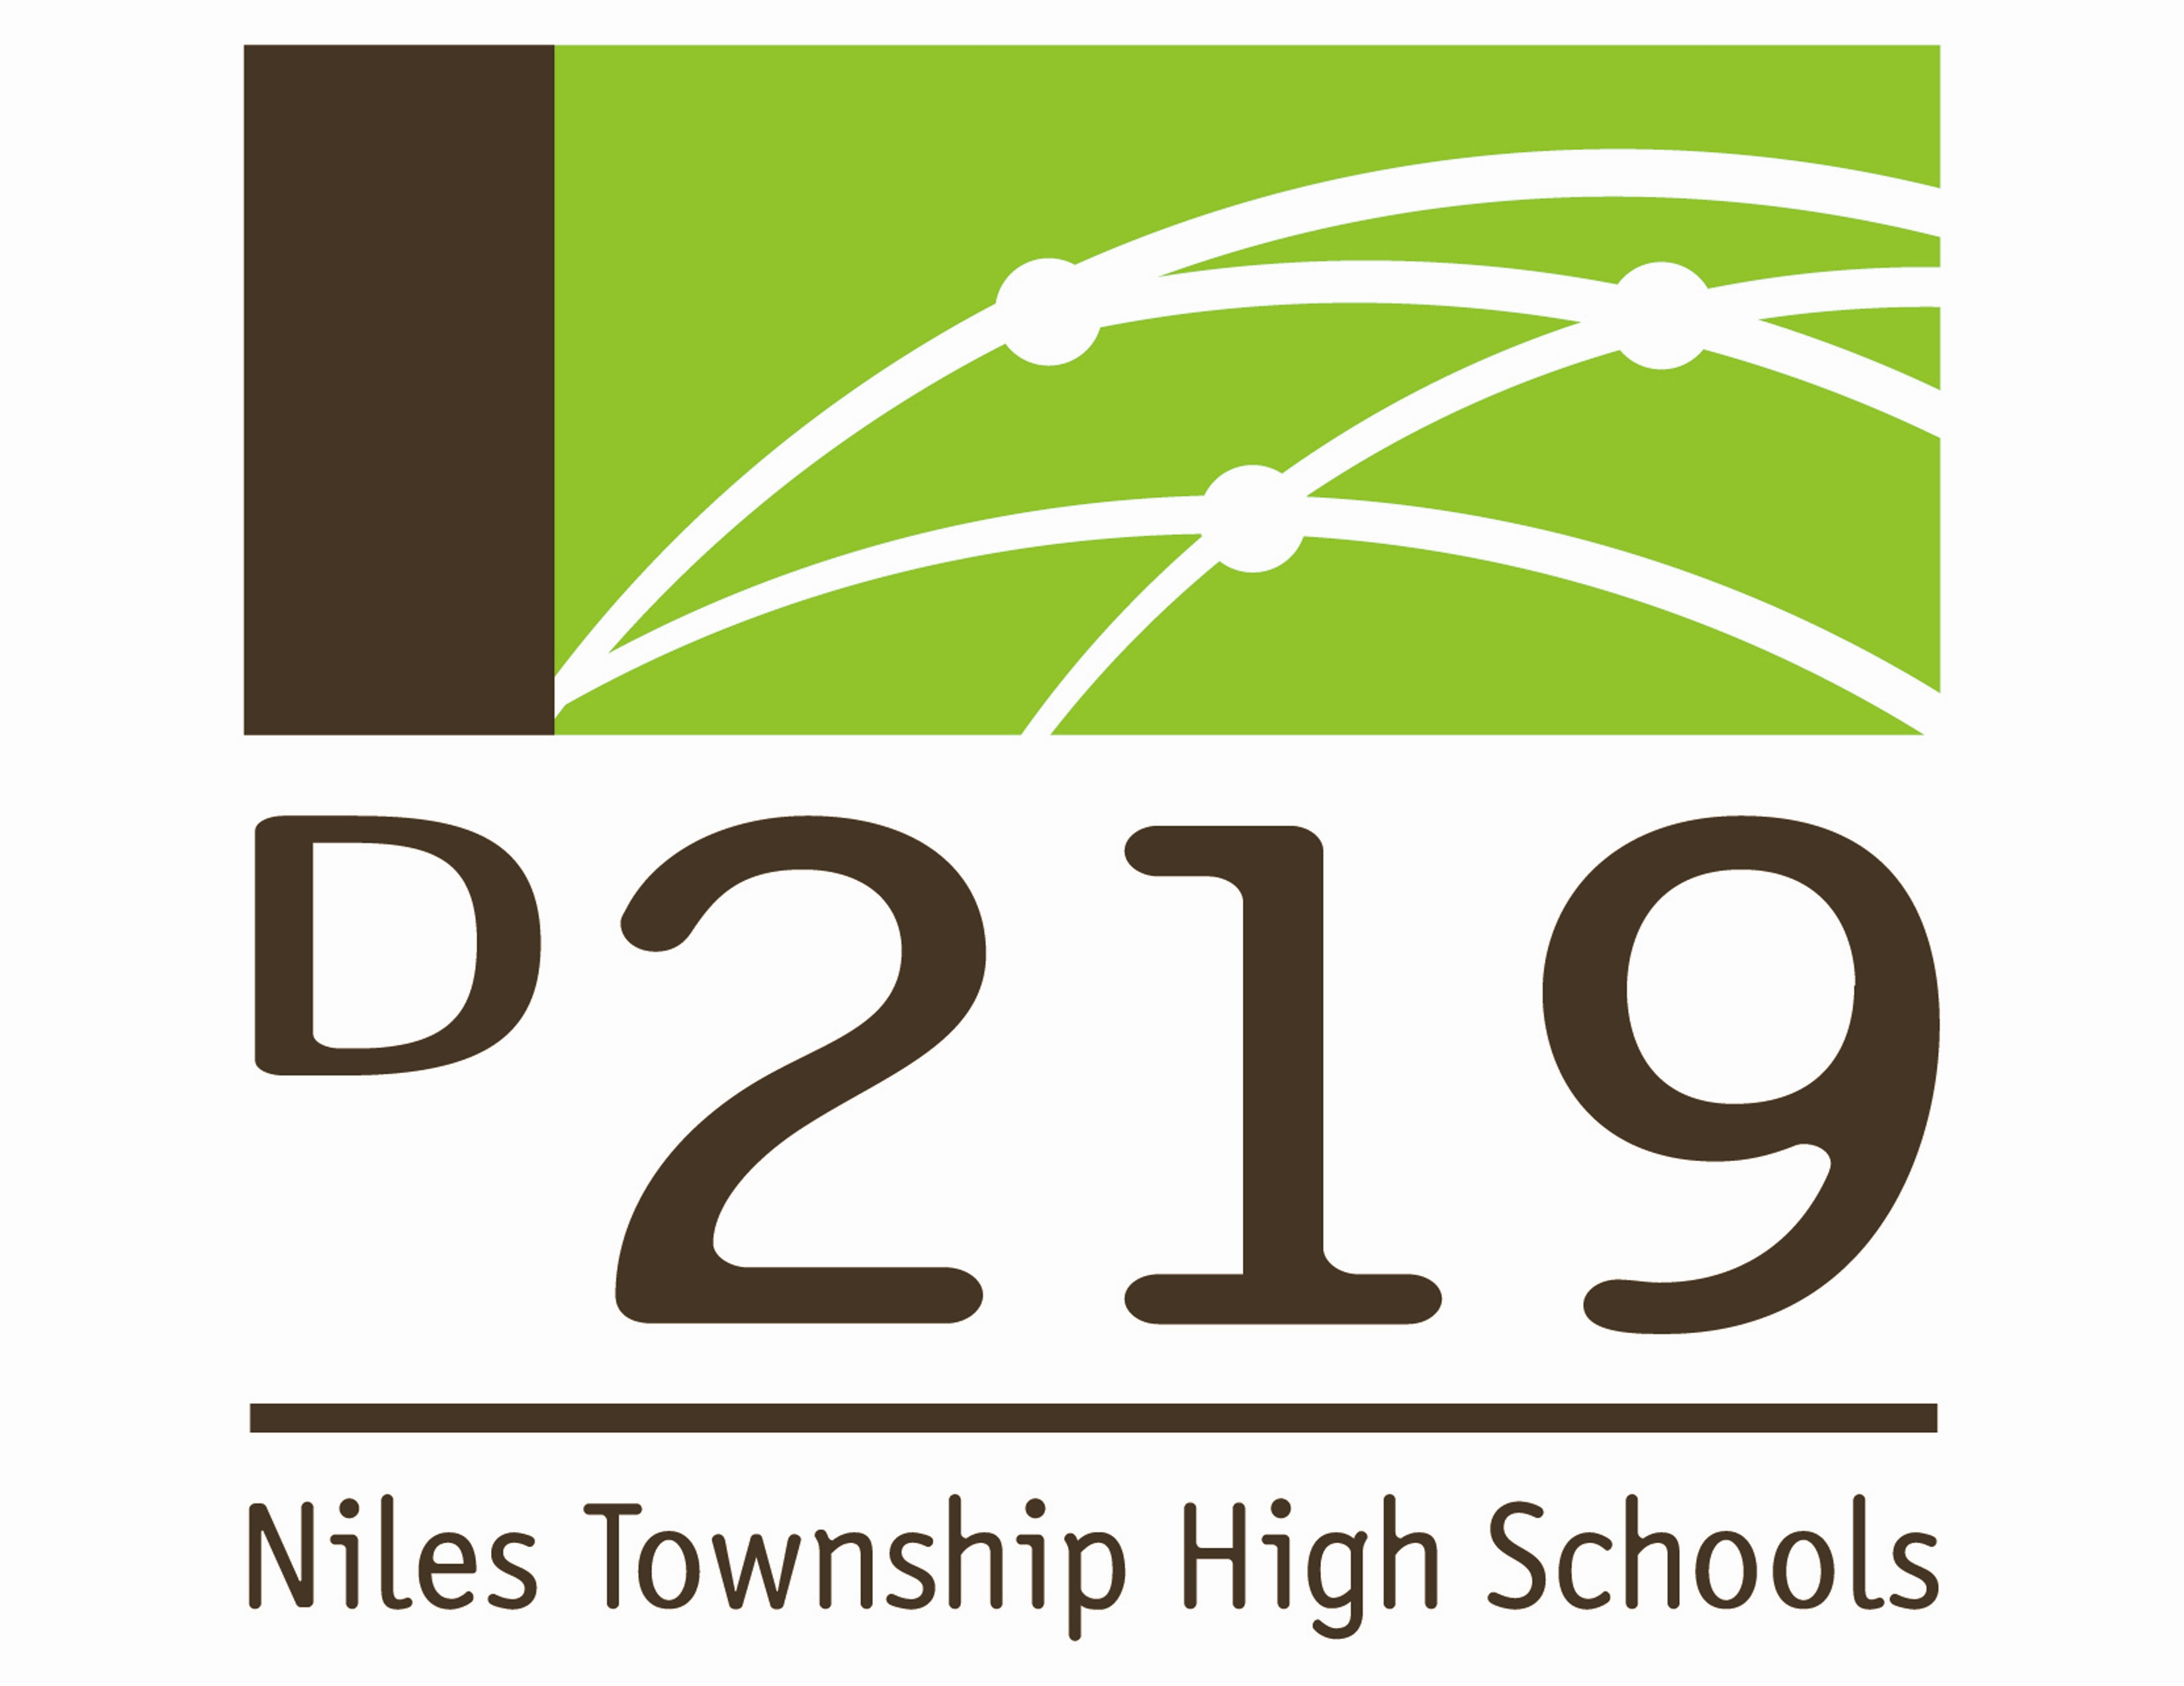

December 6, 2016

Niles Township District 219
Board of Education

Notice of
Finance Committee Meeting

The District 219 Board of Education is planning to hold a Finance Committee meeting on Thursday, December 8, 2016. A meeting agenda is attached.

The meeting will be held in the Board Conference Room of the District 219 Administrative Office Building, located at 7700 Gross Point Road in Skokie.

DATE: Thursday, December 8, 2016

TIME: 6:00 P.M. OPEN SESSION

LOCATION: District 219 Administrative Office Building
7700 Gross Point Road
Skokie, IL 60077

Meeting Agenda
Board of Education ♦Finance Committee
Niles Township High Schools ♦ District 219
December 8, 2016

Call to Order and Roll Call (6:00 p.m.)
- Approval of September 6, 2016 Finance Committee Meeting Minutes
- Summer School Fees
- NSERVE Payment
- 2016 Tax Levy
- Exception Payroll Report
- Red Flag Reporting
- Security Cameras
- Property Tax Bill for 6119 Howard Street
- Feeder IGA (Intergovernmental Agreement)
- Intro to School Finance

